ELCT 302
Laboratory Notebook #1
Open-Loop Control & Obtaining Feedback
Group #2B (Steering Control)
October 9th, 2023

I hereby certify that I have complied
with the Spirit and the Letter
of the Carolinian Creed
in preparing this report

Jacob C. Vaught
Jacob C. Vaught

Department of Electrical Engineering
University of South Carolina
Columbia, SC 29208

Steering Control (Group B) 3
General Objectives 3
Main Specifications 3
Plan of Action (Procedure) 3
Background 3
Calculations 4
Task 1: Open-Loop Control 6
Task 2: Distance Measurement 8
Questions 13
Requirements 14

Steering Control (Group B)

General Objectives
❖ Design and implement a steering system using concepts of resonance, amplification and rectification
❖ Design and implement servo-position control for steering

Main Specifications
❖ Servo voltage: 4.8V - 6V
❖ Communication frequency: 50Hz
❖ Servo Rotational range: 180⁰
❖ Feedback: LC circuit for a given inductance (at 20 kHz)

Plan of Action (Procedure)

Background
We now assume to have a fully operational closed-loop control system capable of setting the vehicle’s speed, measuring that speed, and controlling the speed based on a set point. Since our vehicle is assumed to have forward movement, it is necessary to steer it in order to follow a specified path. The purpose of this lab is to now develop this steering system using a combination of sensor circuitry and software. The track has an embedded wire propagating a 1 amp, 20 kHz square wave signal. We will develop hardware to sense this current and then determine its location in relation to the center of the vehicle so the processor can make appropriate corrections to the steering mechanism.
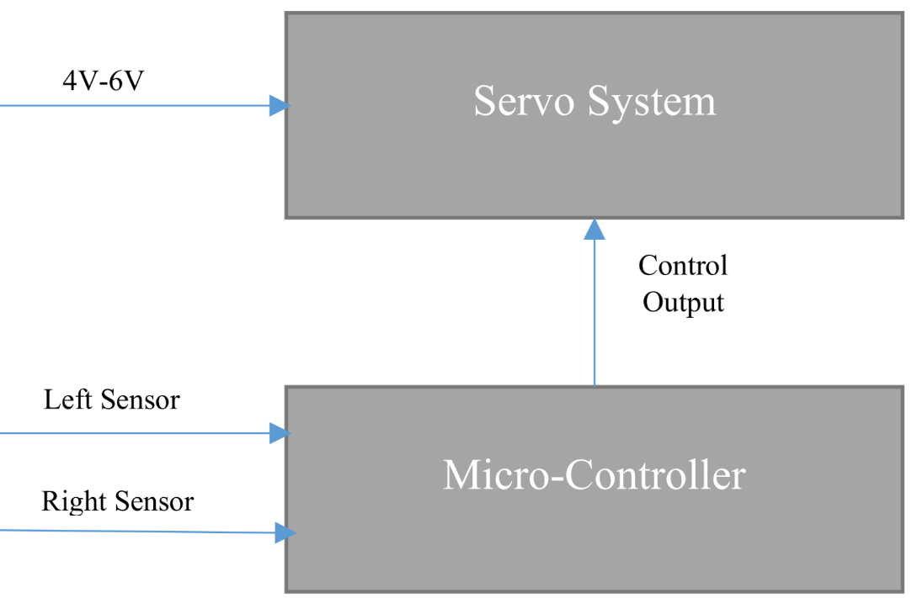
Figure 1. Steering Diagram

Calculations
Lab1:
- Magnetic Distance Sensor:
  - We need 2 sensor circuits
  - One for left and right
- 4 subcircuits
  - LC resonate Circuit
  - Amplification Circuit
  - Rectification Circuit
  - Peak Detection/Low Pass filter Circuit

LC resonant circuit
- Generates signal at 20k frequency
- Track has a 20kHz square wave signal
- Magnetic Flux: $ϕ=B×A=BAcos\left(θ\right)$
- Resonance is: $X_{L}=X_{C}$
$$2πfL_{1}=\frac{1}{2πfC_{1}}$$
$$ω^{2}=\frac{1}{L_{1}C_{1}}→ω=2π*20k≈125, 663.706\frac{rad}{s}$$
PWM 5%-10%
$$D=\frac{T_{on}}{T}$$
$$F=20kHz, L_{1}=100mH$$
Find $C_{1}→2πfL_{1}=\frac{1}{2πfC_{1}}→2π\left(20k\right)\left(100m\right)=\frac{1}{2π\left(20k\right)C_{1}}⇒C_{1}≈633.26pF$
We actually used 650 pF from 470+180pF

Summary: we used 650 pF and 100 mH components to make the Resonator

Amplification Circuit
This subcircuit is a non-inverting amplifier setup, using 2 resistors and an op-amp (LM324)
Transfer function: $V_{out}=V_{in}\left(1+\frac{R_{2}}{R_{1}}\right)$
We determined to use 1k for R1, and 1k for R2 after testing, giving us a gain of: $V_{O}=V_{in}\left(1+\frac{1k}{1k}\right)⇒A=\frac{V_{o}}{V_{in}}=2$
Summary: Non-inverting amplifier with Gain of 2, using 1k resistors.

Rectification Circuit
We use a diode to allow voltage only in one direction to ensure our op-amp feedback network does not get affected by the peak detection and low pass filter circuit.
Output voltage is 0.7 V lower than the source voltage.
Summary: Used a Diode to allow current in one direction.

Peak Detection and Low Pass Filter Circuit
Takes the peak value of the op-amp output and reduces the ripple, creating a “DC” like signal.
- The Capacitor charges up, then slowly discharges through the resistor.
- Ripple requirement is less than 5%
- The smaller the ripple, the larger the time constant(output delay)
- Designer decides tradeoff between the 2
Design Steps
$$V_{ripple}=0.05$$
$$3.25=3.3*\sin\left(θ\right)→θ=80.01°$$
$$t^{''}=\frac{1}{20000}*\frac{80}{360}=0.0000111$$
$$t=t^{''}+\frac{0.75}{20000}=0.00004861111$$
$$3.25=3.3e^{-\frac{t}{RC}}⇒with C=1 μF, then$$
$$\frac{3.25}{3.3}=e^{- \frac{0.00004861111}{RC}}→\frac{3.25}{3.3}=e^{- \frac{0.00004861111}{R*{10}^{-6}}}→R=3183.96Ω$$
Used a 3.3k resistor in actual design.
Summary: Used 3.3k Resistor and 1uF capacitor to create a lowpass filter/peak detection circuit.

Task 1: Open-Loop Control
❖ Design regulation circuit to power servo motor.
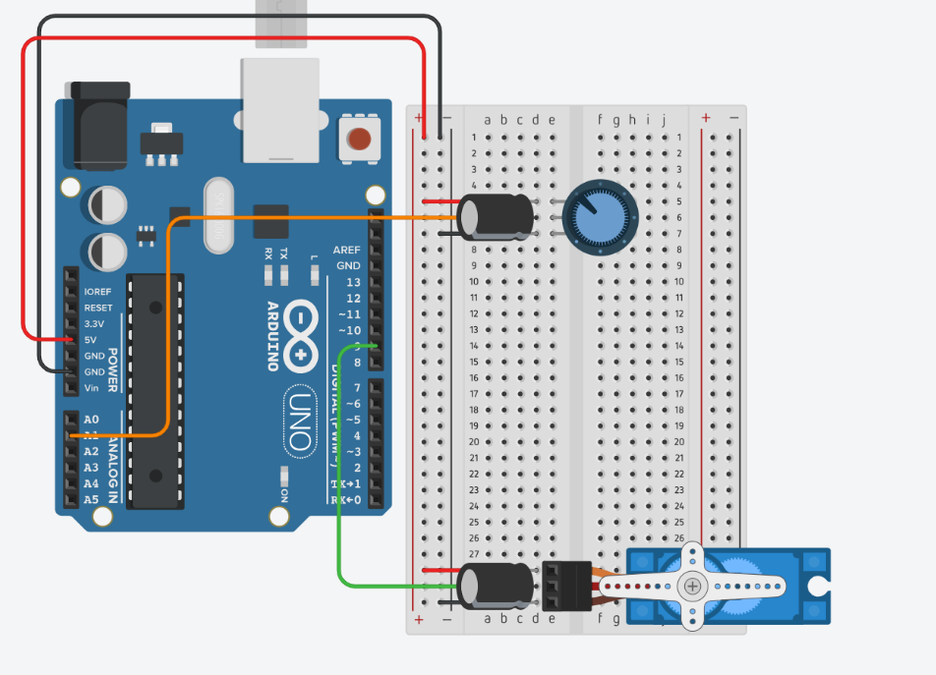
Figure 2. Regulation Circuit
❖ Design a voltage divider circuit with an output ranging from 0-3.3V. (Arduino: 0->5V)
❖ Write code that reads in the voltage divider output as an ADC number, and writes the ratio to the desired maximum as the PWM duty cycle.

Code:
#include <Servo.h>

Servo myservo; // Create servo object
int potPin = A1; // Analog pin A1 for voltage divider
int val; // Value read from voltage divider
void setup() {
myservo.attach(9); // Attaches the servo on pin 9
pinMode(potPin, INPUT); // Sets potPin as INPUT
Serial.begin(9600); // Initialize serial monitor
}
void loop() {
val = analogRead(potPin); // Read voltage from potentiometer
val = map(val, 0, 1023, 0, 180); // Map value to angle (0 - 180)
myservo.write(val); // Set servo angle
Serial.print("Potentiometer Value: ");
Serial.print(val);
Serial.println(" degrees");
delay(15); // Small delay for stability
}

❖ Upload and verify with microcontroller.
❖ Connect servo-motor to microcontroller.
❖ Servo Control
➢ Use a 50 Hz control signal to the servo
➢ Verify for full range of motion. (0⁰ - 180⁰)
• Servo motor receives power from voltage regulator
• Servo motor receives PWM signal from microcontroller
• Servo duty cycle vs position
– Center the servo -- approximately 7.5% duty cycle
– Fully left - approximately 5% duty cycle
– Fully right – approximately 10% duty cycle
– Design this in mbed code.
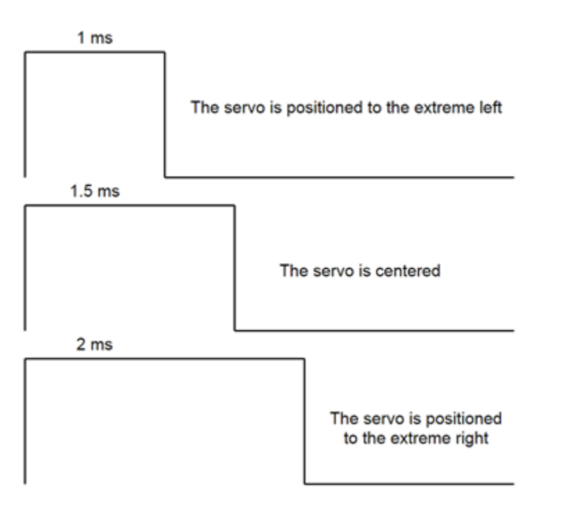
Figure 3. Servo-Motor Control Signal

Task 2: Distance Measurement
❖ Research data sheets for components and understand why they are used (their ratings)
❖ Build this circuit and understand how it works.
➢ VCC should be from a laboratory power supply with a 1 Amp current limit.
➢ Gate Signal should be a square wave from a function generator.
▪ High Side greater than threshold voltage
▪ Low Side at common voltage
▪ Frequency of 20 kHz
➢ Why build a track circuit on the desk?

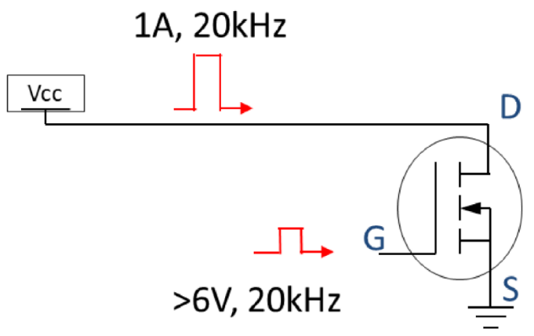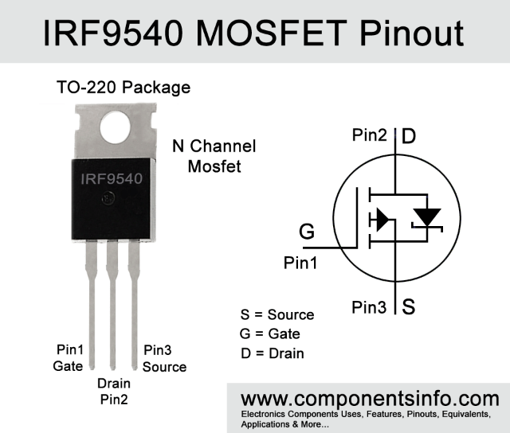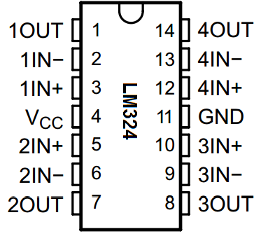

❖ Build the track circuit and understand how it works.
➢ Keep the common-mode input voltage range in mind when choosing a LM324 V+
➢ Take screenshots of the signals at N1, N2, and N3

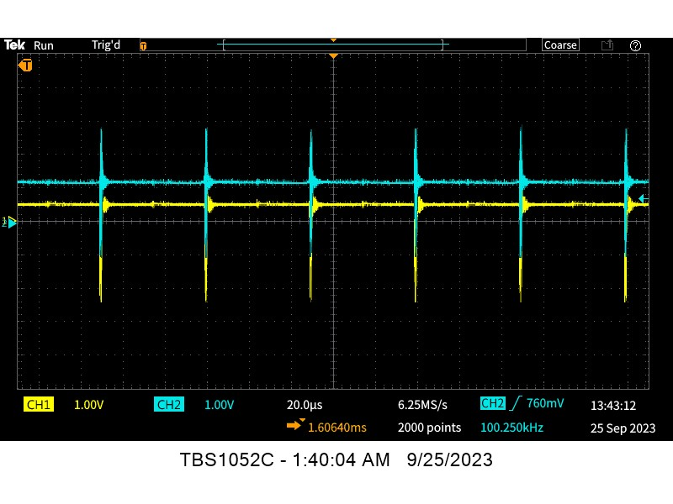
Figure 4. Signal at Node 3 (N3).
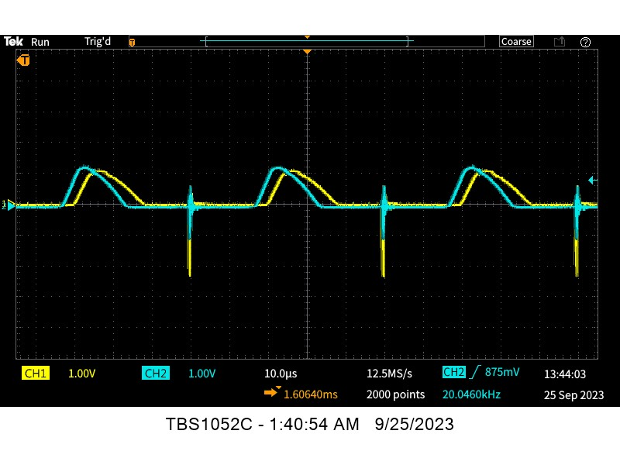
Figure 5. Signal at Node 2 (N2).
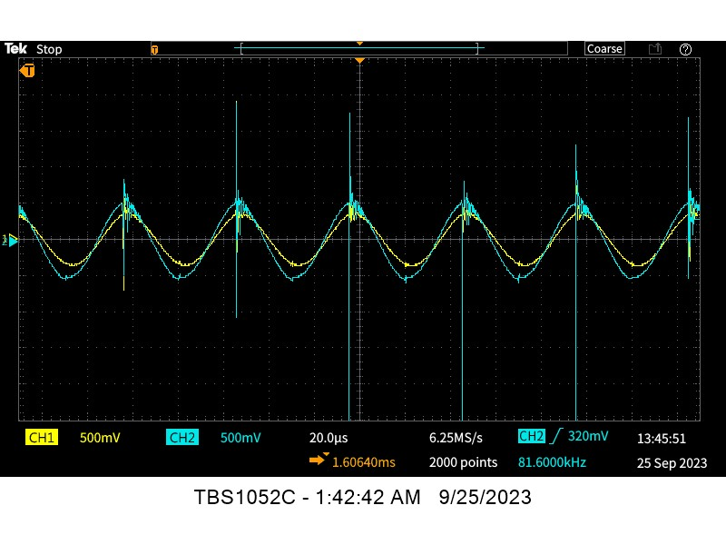
Figure 6. Signal at Node 1 (N1).
➢ Why is the signal seen at the non-inverting input of the LM324 a sine wave when the track signal is a square wave?
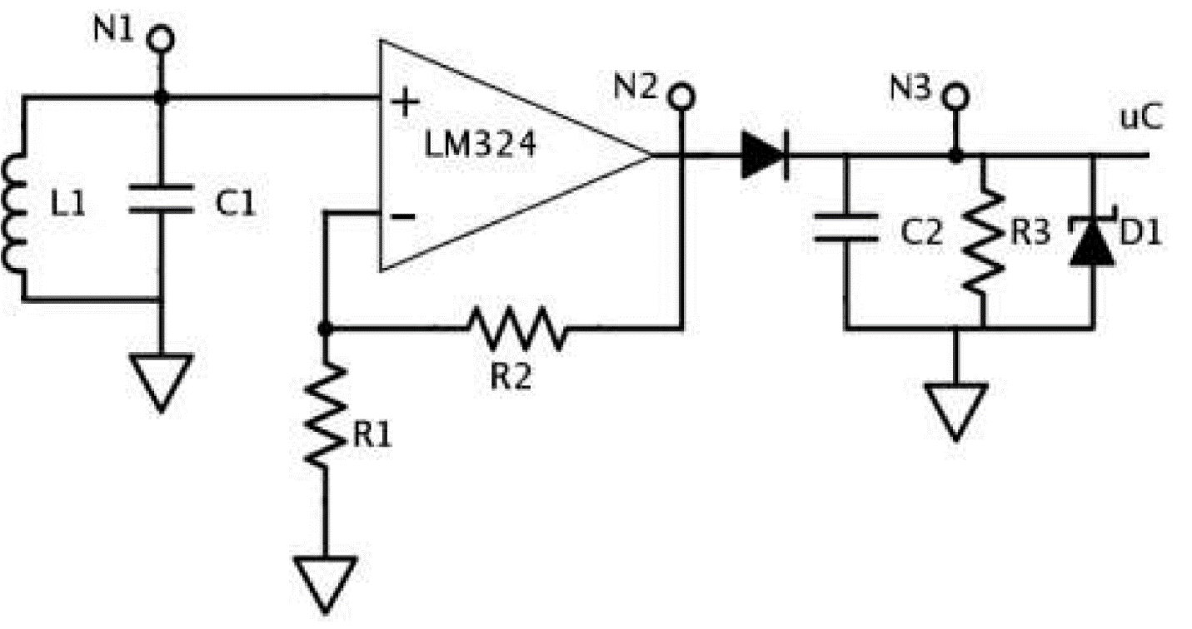
Figure 7. Steering Hardware Schematic

❖ Tabularize the output from both sensors.
➢ Signal distance from center of car (m)
➢ Vout (V), measurement in volts from sensor
➢ VoutADC, measurement voltage digital conversion
Distance: (m from center, left=negative) | Left Vout (V) | Left Vout ADC (V) | Right Vout (V) | Right Vout ADC (V) | Difference of Left and Right Vout ADC (V) {fig 10}
-0.0635 | 0.6 | 3.26 | 0.65 | 3.14 | -0.11
-0.0508 | 0.6 | 2.89 | 0.4 | 3.04 | 0.15
-0.0381 | 3 | 4.5 | 0.5 | 2.5 | -2
-0.0254 | 3 | 2.18 | 0.7 | 3.8 | 1.62
-0.0127 | 2.8 | 3.69 | 0.25 | 2.38 | -1.31
0 | 0.5 | 3.67 | 0.5 | 3.7 | 0.03
0.0127 | 0.5 | 2.41 | 2 | 3.96 | 1.55
0.0254 | 0.8 | 2.12 | 2.8 | 3.98 | -1.86
0.0381 | 2.5 | 3.9 | 3 | 4.23 | 0.33
0.0508 | 0.4 | 3.27 | 0.6 | 2.8 | -0.47
0.0635 | 1 | 2.92 | 0.7 | 3.2 | 0.28

Code:
// Initialize variables for storing analog readings
int analogValueA0 = 0;
int analogValueA1 = 0;
// Initialize variables for storing voltage values
float voltageA0 = 0.0;
float voltageA1 = 0.0;
float voltageDifference = 0.0;
void setup() {
// Start Serial communication
Serial.begin(9600);
}
void loop() {
// Read analog values from A0 and A1
analogValueA0 = analogRead(A0);
analogValueA1 = analogRead(A1);
// Convert analog readings to voltage
voltageA0 = (analogValueA0 * 5.0) / 1023.0;
voltageA1 = (analogValueA1 * 5.0) / 1023.0;
// Calculate the difference in voltage
voltageDifference = voltageA0 - voltageA1;
// Print voltages and their difference to Serial Monitor
Serial.print("Voltage on A0: ");
Serial.print(voltageA0, 2); // Two decimal places
Serial.print(" V\t"); // Tab for alignment
Serial.print("Voltage on A1: ");
Serial.print(voltageA1, 2); // Two decimal places
Serial.print(" V\t"); // Tab for alignment
Serial.print("Voltage Difference: ");
Serial.print(voltageDifference, 2); // Two decimal places
Serial.println(" V");
// Delay for a bit before the next reading
delay(1000);
}

❖ Graph the distance of the car to center of track vs output voltage of each sensor

Figure 8. Graph of the Distance of Car to Center of Track vs Output Voltage of each Sensor.
❖ Graph the distance of the car to center of track vs output difference of the sensors
➢ A check of linearity by using interpolation will complete this lab. Superimpose the average slope on the plot and include the slope’s equation.

Figure 9. Graph of the Distance of Car to Center of Track vs Output Difference of each Sensor.

Questions
- Why create a linear representation of the final graph?
  - To better understand the relationship between the output voltage ADC and the distance (m).
  - It shows the accuracy of the sensors.
- What is the operational range of the sensor?
  - Arduino: 0V-5V
- Is there a delay in the sensor and is this delay negligible?
  - Yes, there is a delay in the sensor, but it is negligible.
- What is the purpose of the two diodes in the circuit? Could one of these diodes be removed?
  - Diodes are used for conducting the current in one direction (a positive direction).
  - The Zener diode is not necessary and we did not include it in our circuit design.
- What are the four stages of the sensing circuit above?
  - LC Resonate Circuit
    - Inductor: L1
    - Capacitor: C1
  - Amplification Circuit
    - Op-Amp (Operational Amplifier): LM324
    - 2 Resistors: R1 & R2
  - Rectification Circuit
    - Diode
  - Peak Detection Low Pass Filter
    - Capacitor: Cp
    - Resistor: Rp

Many many multitudes of Problems
Problems: | Solutions:
Finding correct resistor values; Started out using a potentiometer. | Used 1 kohm resistor for R1 and R2
Soldered diode in the wrong direction | Put diode in the correct direction
MBED microcontroller stopped working properly | Had to use Arduino and change code to be compatible with Arduino
Arduino has operational range of 0-5V and MBED only had operational range of 0-3V; Zener diode of 3.3V does not work | Zener diode is not necessary, so we took it out.
Soldered circuit to PERF board; did not function | Built on a breadboard
Built a single component to do house the 4 subcircuits for each circuit. Did not work. | Abandoned high-level manufacturing concept.
Op-Amp was not working without the negative input. | Switched to Texas Instrument LM324 Op-amp instead of generic brand

Requirements
❖ Check-off requirements:
➢ Demonstrate servo control over entire range using ADC →PWM
➢ Answer questions listed above, and any questions from the instructor and/or TA.
➢ Lab notebook (When? Who? What happened? Schematics and explanations)
➢ Demonstrate servo control and feedback covering the entire range (including 0)
➢ Table with at least 10 data points shown and measurements/calculations explained
➢ Trend line of interpolation must be within range of expected values
❖ Check-off report: (Group)
➢ Refer to rubric and template from Blackboard
➢ Be sure to include:
▪ Encoder/sensor/converter design procedure and explanation
▪ Results presentation (include o-scope images, measurement records, etc.)
▪ Results analysis and discussion
▪ Hardware schematic (using PSpice, TinyCAD, EAGLE, etc.)
▪ Problem solving (describe problems you encountered and how you solved them)

